**Assignment-1**

**1.What is software? What is software engineering?**

*Ans*-Software is a set of instructions or programs that tell a computer what to do Software is the digital tool that enables computers to perform tasks, like running apps, browsing the internet, or editing documents and carry out tasks and run programs.

*{What is Software engineering}*

~software engineering is the creating designing and maintaining software applications

.

**2. explain type of software?**

*Ans-***system** **software**-system software that manages computer hardware and provides a platform for running application software

**~Application software –** application software designed for specific tasks for applications

**~programming software-**programming software used by developers create, debug, and maintain

Software application.

~**middleware-** middleware software that acts as a bridge between different application or system for communication and data exchange.

~**utilities-**programs that perform specific tasks to enhance computer performance or maintain system health like antivirus software.

**~embedded software-**software within hardware devices to control their functions its often found in devices like smartphones, appliances, automotive system.

**3.what is SDLC? Explain each phase of SDLC?**

*Ans****-*** SDLC is software development life cycle is a structured approach used by developers to plain create, test and maintain software throughout their lifecycle.

**Phase of SDLC -**

1.analysis- analysis involves understanding user requirements studying and defining software specifications to determine what the software should accomplish.

2.design- design creating a blueprint or plan for the software solution, outline user interface and technical specifications based on the gathered requirements.

3.planning- planning setting project goals, defining objectives and establishing timelines to ensure the successful execution of the software development.

4.implementation- translating the design specifications into actual code by writing and assembling the software components according to the planned architecture and functionality.

5.testing- testing to identify and fix bugs or issues before deployments.

6.deployment- making its available for users by installing it on their systems or servers, and ensuring it functions as intended in real world scenarios.

7.maintenance- addressing issues, making updates and secure and efficient over time, even after deployment.

**4. What is DFD? Create a DFD diagram on Flipkart**

*Ans-*DFD for data flow diagram, a graphical representation used to visualize the flow data within system data stores, and data movement between them.

**~make flowchart addition two numbers:**

**~DFD diagram level 0:**

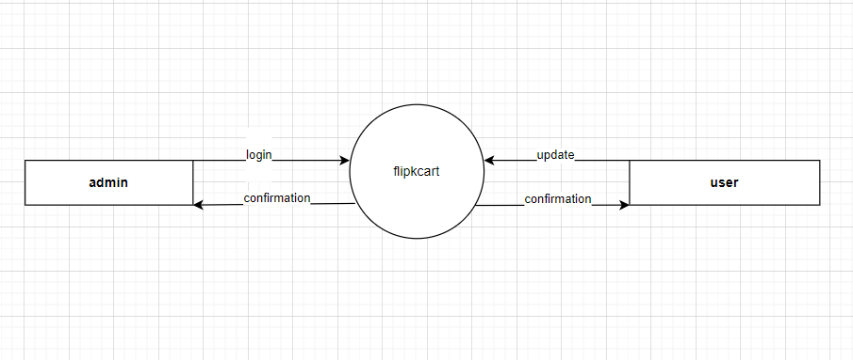

**~~DFD diagram level 1:**

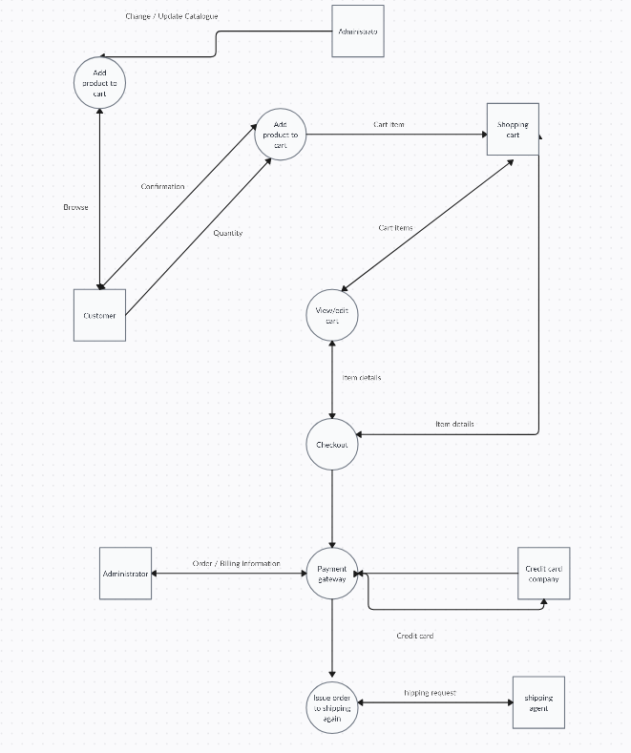

**~DFD diagram level 2:**

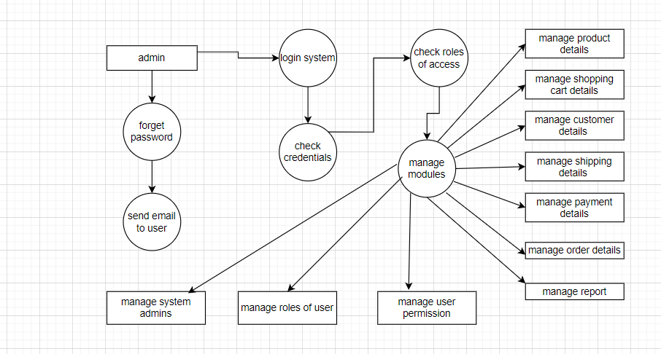

**6.What is Use case Diagram? Create a use-case on bill payment on paytm**

***Ans****-* A use case diagram is a visual representation in Unified Modeling Language (UML) that depicts the interactions between actors (users or external systems) and a system, illustrating the system's functionalities and

**~create a use-case on bill payment on paytm-**

